**PROJECT REPORT**

***Loan Default Prediction using Machine Learning Techniques***

*Submitted towards the partial fulfillment of the criteria for award*

*of*

*Genpact Data Science Prodegree by Imarticus*

*Submitted By:*

*Mrunal Joshi*

*Kush Trivedi*

*Course and Batch: DSP-22 September 2019*



# Abstract

**Keywords**

*Disclaimer: *Data shared by the customer is confidential and sensitive, it should not be used for any purposes apart from capstone project submission for DSP. The Name and demographic details of the enterprise is kept confidential as per their owners’ request and binding.*

# Acknowledgements

We are using this opportunity to express our gratitude to everyone who supported us throughout the course of this group project. We are thankful for their aspiring guidance, invaluably constructive criticism and friendly advice during the project work. I am sincerely grateful to them for sharing their truthful and illuminating views on a number of issues related to the project.

Further, we were fortunate to have **Ravindra Paul** as our mentor. He has readily shared his immense knowledge in data analytics and guided us in a manner that the outcome resulted in enhancing our data skills.

We wish to thank, all the faculties, as this project utilized knowledge gained from every course that formed the DSP program.

We certify that the work done by us for conceptualizing and completing this project is original and authentic.

Date: May 23, 2020 Member 1: Mrunal Joshi

Place: Pune Member 2: Kush Trivedi

# Certificate of Completion

I hereby certify that the project titled “**Loan Prediction Default using Machine Learning Techniques**” was undertaken and completed under my supervision by **Mrunal Joshi** and **Kush Trivedi** from the batch of DSP-22 (Sept 2019)

Mentor: Ravindra Paul

Date: May 23, 2020

Place – Pune

Table of Contents

Abstract 2

Acknowledgements 2

Certificate of Completion 3

CHAPTER 1: INTRODUCTION 5

1.1 Title & Objective of the study 5

1.2 Need of the Study 5

1.3 Business Model of Enterprise 5

1.4 Data Sources 5

1.5 Tools & Techniques 6

1.6 Infrastructure Challenges 6

CHAPTER 2: DATA PREPARATION AND UNDERSTANDING 6

2.1 Data Extraction and Cleaning 6

2.2 Data Dictionary 9

2.3 Exploratory Data Analysis 11

2.4 Feature Selection 17

CHAPTER 3: SCALING & SAMPLING THE DATA 20

3.1 SCALING DATA USING MIN-MAX SCALER 20

3.2 SAMPLING DATA USING STRATIFIED SAMPLING TECHNIQUE 20

CHAPTER 4: FITTING MODELS TO DATA 21

4.1 LINEAR REGRESSION MODEL 21

4.2 RANDOM FOREST MODEL 23

CHAPTER 5: OPTIMAL THRESHOLD SELECTION 24

CHAPTER 6: RE-FITTING THE MODEL AFTER APPLYING OPTIMAL THRESHOLD 25

6.1 LINEAR REGRESSION MODEL 25

6.2 RANDOM FOREST MODEL 26

CHAPTER 7: MODEL CROSS-VALIDATION 27

7.1 LINEAR REGRESSION MODEL 27

7.2 RANDOM FOREST MODEL 28

CHAPTER 8: CONCLUSION & KEY FINDINGS 29

CHAPTER 9: RECOMENDATION 30

# CHAPTER 1: INTRODUCTION

## Title & Objective of the study

The objective of our project is to predict whether a loan will default or not based on objective financial data only and whether investors should lend to a customer or not. Data from 2007-2015 will be used because most of the loans from that period have already been repaid or defaulted on.

## Need of the Study

In today’s world, obtaining loans from financial institutions has become a very common phenomenon. Every day many people apply for loans, for a variety of purposes. But not all the applicants are reliable, and not everyone can be approved. Every year, there are cases where people do not repay the bulk of the loan amount to the bank which results in huge financial loss. The risk associated with making a decision on a loan approval is immense. Hence, the idea of this project is to gather loan data from the Lending Club website and use machine learning techniques on this data to extract important information and predict if a customer would be able to repay the loan or not. In other words, the goal is to predict if the customer would be a defaulter or not.

## 1.3 Business Model of Enterprise

Financial lending is a way to borrow without using a traditional bank or credit union. For applicants with a good credit score (often a FICO credit score higher than 720), P2P loan rates can be surprisingly low. With less-than-perfect credit, an applicant still has a decent shot at being approved for an affordable loan with online lenders like XYZ corporation.

Financial loans are loans made by individuals and investors – as opposed to loans that come from a bank. People with extra funds offer to lend that money to others (individuals and businesses) in need of cash. A P2P service (such as a website) matches lenders and borrowers so that the process is relatively easy for all involved.

## 1.4 Data Sources

The provided dataset corresponds to all loans issued to individuals in the past from 2007-2015. The dataset has 855969 observations and 73 features. The data contains the indicator of default, payment information, credit history, etc. Customers under 'current' status have been considered as non-defaulters in the dataset. We have also been provided with a Data dictionary that best describes the features.

The dataset has quite a lot of missing values and the figures can be considered as ground truth, but lots of columns are either irrelevant, very sparse or non-informative. Moreover, the dataset is unbalanced, with approximately 6% of loans considered as defaulted.

## 1.5 Tools & Techniques

Tools: Python 3.7.2, Jupyter Notebook, Numpy, Pandas, Matplotlib, Seaborn, Scikit-learn, SciPy

Techniques: Logistic regression, Random Forest Classifier

## 1.6 Infrastructure Challenges

1. The modus operandi of credit rating by banks and rating agencies.

2. The impact of economic downturn on the behaviors of borrowers as well as lenders.

3. Mode of calculation of default probability

# CHAPTER 2: DATA PREPARATION AND UNDERSTANDING

One of the first steps we engaged in was to outline the sequence of steps that we will be following for our project. Each of these steps are elaborated below.

## 2.1 Data Extraction and Cleaning:

* **Missing Value Analysis and Treatment**

In our dataset our target shows that 95% have not defaulted and 5% are defaulters or charged off. So, this is clearly an unbalanced dataset.

The first issue was to know if the columns were filled with useful information or were mostly empty. Data exploration uncovered many empty or almost empty columns which were removed from the dataset because it would prove a difficult task to go back and try to answer for each data point that did not seem necessary at the time of the loan application.

Our dataset has 855969 rows × 73 features including the target out of which 32 have missing values or NAN. Below we will look at a plot and get some insights.

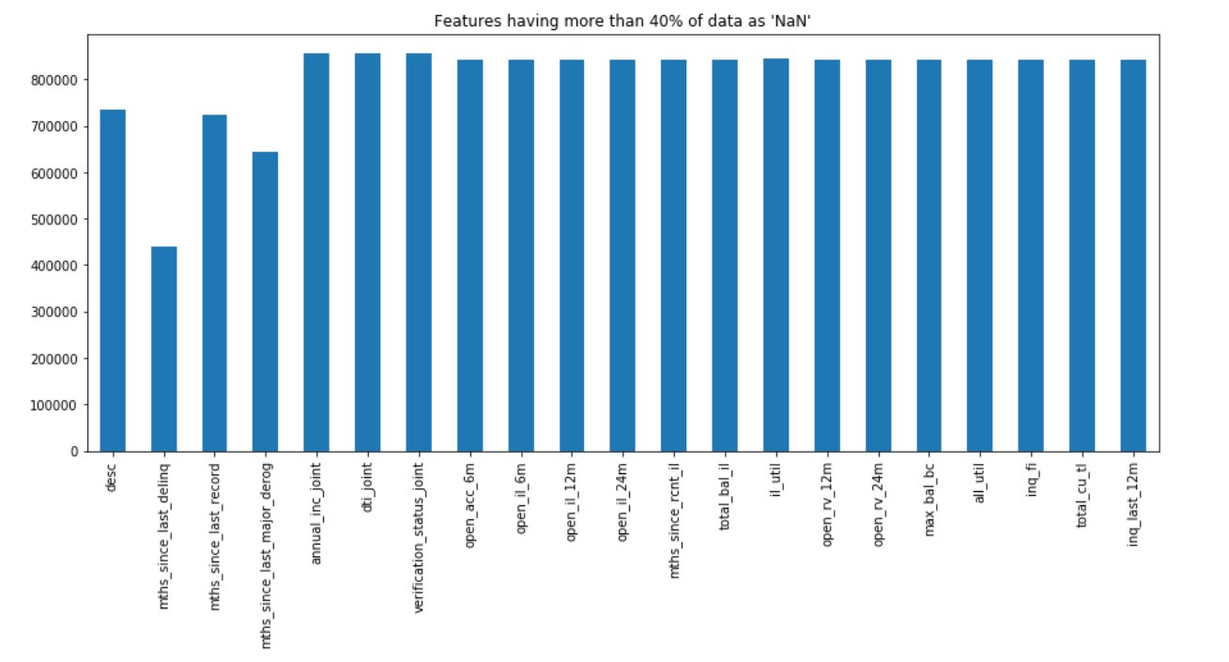

Insights: So, we can see from the above plot that there is 20+ columns in the dataset where all the values are NA.

As we can see there are 855969 observations & 73 columns in the dataset, it will be very difficult to look at each column one by one & find the NA or missing values. So, let's find out all columns where missing values are more than certain percentage, let's say 75%. We will remove those columns as it is not feasible to impute missing values for those columns.

Out of 73 features we only kept 53. So, we removed about 21 features that had more than 75% missing values since it will not make any sense in further exploration.

**We need to especially pay close attention to data leakage**, which can cause the model to overfit. This is because the model would be also learning from features that wouldn’t be available when we’re using it make predictions on future loans.

We checked the variance and are removing low variance variables (excluding out target). However, since this is a sensitive problem we will remove based on our own discretion and business knowledge. Some irrelevant columns Unique ID's such as "id","member_id" because they did not provide any useful information about the customer. As last 2 digits of zip code is masked 'xx', we can remove that as well.

We still had five more features with null values (emp_length, revol_util, tot_coll_amt, tot_cur_bal, total_rev_hi_lim) which we have imputed using fillna method using the appropriate statistic.

* **Unique value treatment**

We identified 6 features having high unique values which are as follows:

emp_title, title, earliest_cr_line, addr_state, last_credit_pull_d, last_pymnt_d

We dropped above features.

## 2.2 Data Dictionary

|  |  |
| --- | --- |
| **Variable Name** | **Description** |
| addr_state | The state provided by the borrower in the loan application |
| annual_inc | The self-reported annual income provided by the borrower during registration. |
| annual_inc_joint | The combined self-reported annual income provided by the co-borrowers during registration |
| application_type | Indicates whether the loan is an individual application or a joint application with two co-borrowers |
| collection_recovery_fee | post charge off collection fee |
| collections_12_mths_ex_med | Number of collections in 12 months excluding medical collections |
| delinq_2yrs | The number of 30+ days past-due incidences of delinquency in the borrower's credit file for the past 2 years |
| desc | Loan description provided by the borrower |
| dti | A ratio calculated using the borrower’s total monthly debt payments on the total debt obligations, excluding mortgage and the requested loan, divided by the borrower’s self-reported monthly income. |
| dti_joint | A ratio calculated using the co-borrower’s total monthly payments on the total debt obligations, excluding mortgages and the requested loan, divided by the co-borrowers' combined self-reported monthly income |
| earliest_cr_line | The month the borrower's earliest reported credit line was opened |
| emp_length | Employment length in years. Possible values are between 0 and 10 where 0 means less than one year and 10 means ten or more years. |
| emp_title | The job title supplied by the Borrower when applying for the loan. |
| funded_amnt | The total amount committed to that loan at that point in time. |
| funded_amnt_inv | The total amount committed by investors for that loan at that point in time. |
| grade | XYZ corp. assigned loan grade |
| home_ownership | The home ownership status provided by the borrower during registration. Our values are: RENT, OWN, MORTGAGE, OTHER. |
| id | A unique assigned ID for the loan listing. |
| initial_list_status | The initial listing status of the loan. Possible values are – W, F |
| inq_last_6mths | The number of inquiries in past 6 months (excluding auto and mortgage inquiries) |
| installment | The monthly payment owed by the borrower if the loan originates. |
| int_rate | Interest Rate on the loan |
| issue_d | The month which the loan was funded |
| last_credit_pull_d | The most recent month XYZ corp. pulled credit for this loan |
| last_pymnt_amnt | Last total payment amount received |
| last_pymnt_d | Last month payment was received |
| loan_amnt | The listed amount of the loan applied for by the borrower. If at some point in time, the credit department reduces the loan amount, then it will be reflected in this value. |
| loan_status | Current status of the loan |
| member_id | A unique Id for the borrower member. |
| mths_since_last_delinq | The number of months since the borrower's last delinquency. |
| mths_since_last_major_derog | Months since most recent 90-day or worse rating |
| mths_since_last_record | The number of months since the last public record. |
| next_pymnt_d | Next scheduled payment date |
| open_acc | The number of open credit lines in the borrower's credit file. |
| out_prncp | Remaining outstanding principal for total amount funded |
| out_prncp_inv | Remaining outstanding principal for portion of total amount funded by investors |
| policy_code | publicly available policy_code=1 new products not publicly available policy_code=2 |
| pub_rec | Number of derogatory public records |
| purpose | A category provided by the borrower for the loan request. |
| pymnt_plan | Indicates if a payment plan has been put in place for the loan |
| recoveries | post charge off gross recovery |
| revol_bal | Total credit revolving balance |
| revol_util | Revolving line utilization rate, or the amount of credit the borrower is using relative to all available revolving credit. |
| sub_grade | XYZ assigned loan subgrade |
| term | The number of payments on the loan. Values are in months and can be either 36 or 60. |
| title | The loan title provided by the borrower |
| total_acc | The total number of credit lines currently in the borrower's credit file |
| total_pymnt | Payments received to date for total amount funded |
| total_pymnt_inv | Payments received to date for portion of total amount funded by investors |
| total_rec_int | Interest received to date |
| total_rec_late_fee | Late fees received to date |
| total_rec_prncp | Principal received to date |
| verified_status_joint | Indicates if the co-borrower’s joint income was verified by XYZ corp., not verified, or if the income source was verified |
| zip_code | The first 3 numbers of the zip code provided by the borrower in the loan application. |
| open_acc_6m | Number of open trades in last 6 months |
| open_il_6m | Number of currently active installment trades |
| open_il_12m | Number of installment accounts opened in past 12 months |
| open_il_24m | Number of installment accounts opened in past 24 months |
| mths_since_rcnt_il | Months since most recent installment accounts opened |
| total_bal_il | Total current balance of all installment accounts |
| il_util | Ratio of total current balance to high credit/credit limit on all install acct |
| open_rv_12m | Number of revolving trades opened in past 12 months |
| open_rv_24m | Number of revolving trades opened in past 24 months |
| max_bal_bc | Maximum current balance owed on all revolving accounts |
| all_util | Balance to credit limit on all trades |
| total_rev_hi_lim | Total revolving high credit/credit limit |
| inq_fi | Number of personal finance inquiries |
| total_cu_tl | Number of finance trades |
| inq_last_12m | Number of credit inquiries in past 12 months |
| acc_now_delinq | The number of accounts on which the borrower is now delinquent. |
| tot_coll_amt | Total collection amounts ever owed |
| tot_cur_bal | Total current balance of all accounts |
| verification_status | Was the income source verified |

## 2.3 Exploratory Data Analysis:

* **Loan Status**

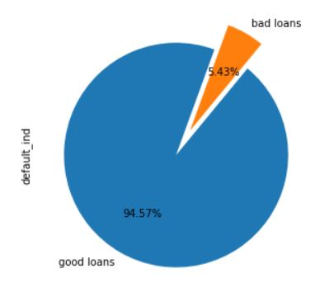

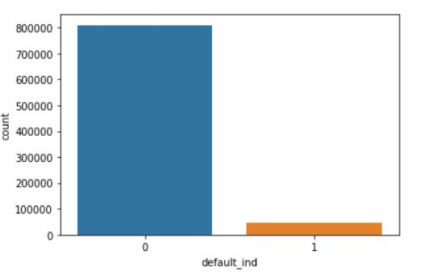

Our target variable ‘default_ind’ is highly biased towards the non-defaulter class (0) as seen in above figures.

* **Loan Amount vs Issue year**

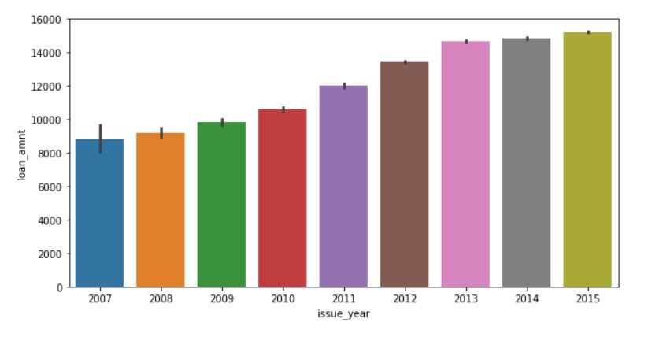

2015 was the year when most amount of loans were issued and loans were issued in incremental manner as seen in above graph.

* **Relation between Loan Grade & Target variable**

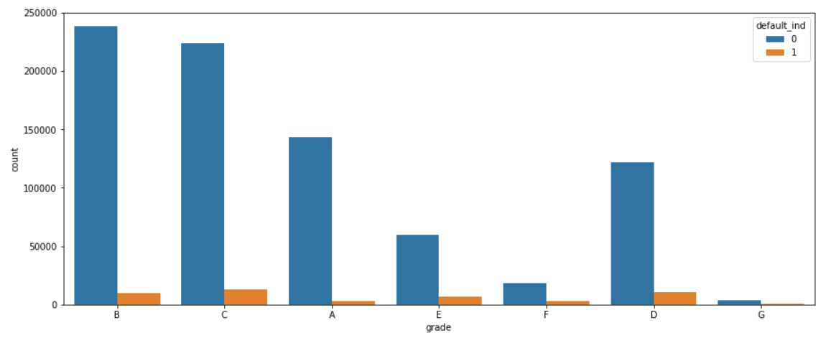

As seen in first graph of loan grade it is clear that the greatest number of defaulters are from grade C and grade B accounts for the maximum number of loans issued.

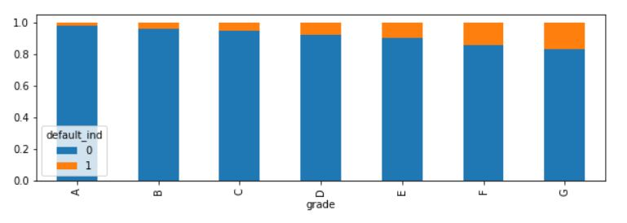

Above graph of loan grade is indicating percentage distribution of defaulters among the different loan grades.

Loan grade G is having higher percentage of defaulters among all other loan grades as seen in above graph.

* **Relation between Loan Purpose & Target variable**

# 

As seen in above graph, Debt consolidation accounts for the most numbers of loan application by the borrowers.

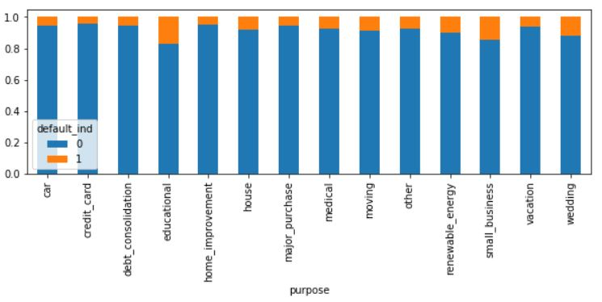

Above graph indicates the percentage distribution of defaulters among different purposes.

Education and Small business are key factors to be taken into consideration while approving the loan due to higher percentage of default as seen in above figure.

* **Relation between Home Ownership & Target variable**

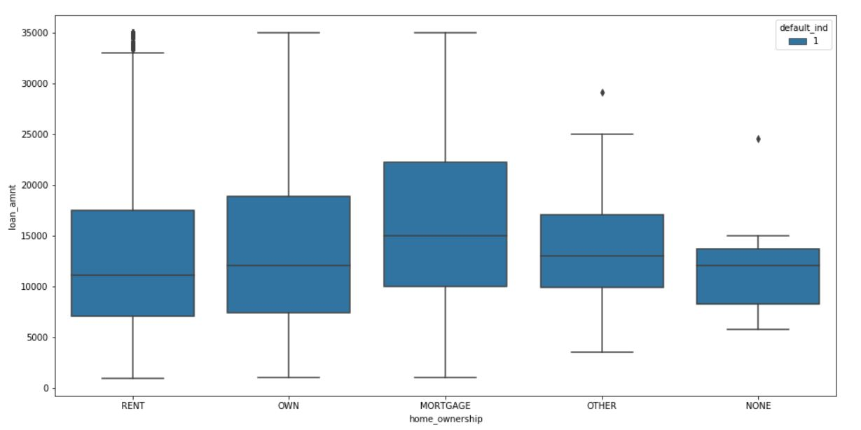

As seen in above plot, Applicants having mortgage are more likely to default with high average loan amount compared to other categories in home ownership.

In short, applicants having mortgage are more likely to default with high loan amount.

* **Similar distribution of features**

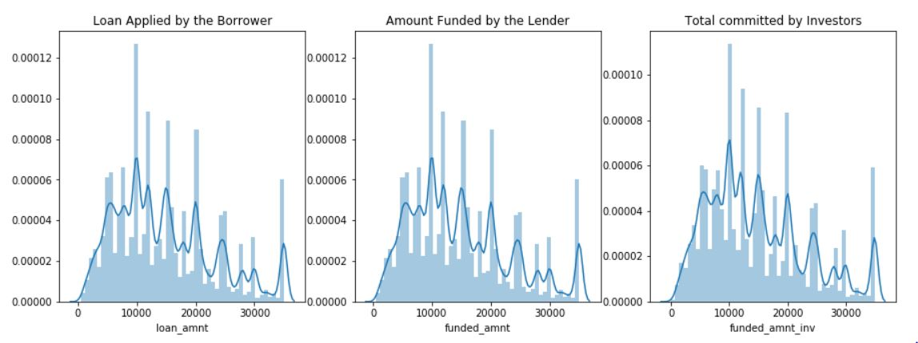

As seen in above figure Loan amount, Funded amount and Total amount committed by investors have similar distribution.

The loans applied by potential borrowers, the amount issued to the borrowers and the amount funded by investors are similarly distributed, meaning that it is most likely that qualified borrowers are going to get the loan they had applied for.

* **Relation between Interest rate and Target variable**

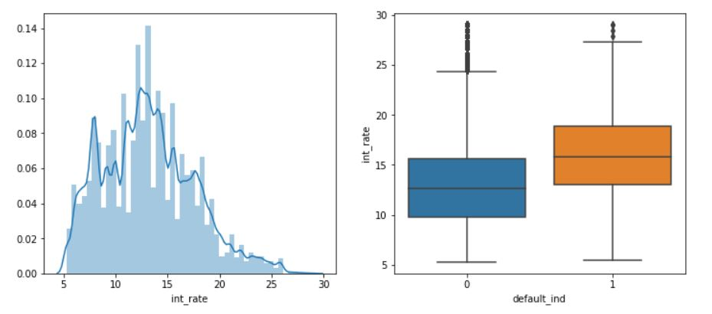

As seen in above box plot that Borrower having higher interest rate on their loans are more likely to default.

## 2.4 Feature Selection

* **Co-relation analysis and Corr-plot**



We did co-relation plotting on numeric data to identify highly co-related variables.

We identified 8 highly co-related variables but, We didn’t dropped them because p-value analysis was identifying them as significant variables.

The highly co-related features are as follow:

1. collection_recovery_fee
2. funded_amnt
3. funded_amnt_inv
4. installment
5. out_prncp_inv
6. total_pymnt_inv
7. total_rec_prncp
8. total_rev_hi_lim

* **Chi-Square Test for categorical variables**

We did Chi-square analysis between our categorical variables and target variable.

All the categorical variables were rejecting null-hypothesis.

Following are the categorical variables tested for significance:

1. term
2. grade
3. home_ownership
4. verification_status
5. purpose
6. initial_list_status

* **One to Many ANOVA testing**

We did one to many anova testing to identify the p-values of each feature.

Most significant feature according to One to Many ANOVA testing is as follows:

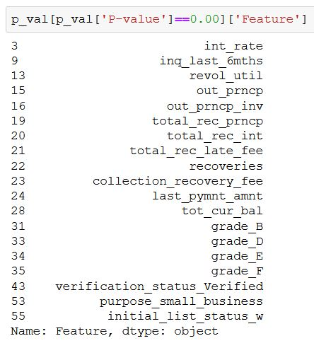

We dropped the feature which were less significant according to their p-value; Feature which were less significant are as follows:

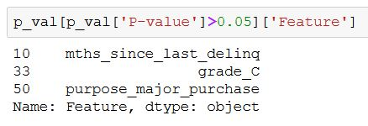

* **VIF Testing for multicollinearity**

We selected around 9 feature who were highly co-related according to VIF scores.

To reduce effect of collinearity in our model we dropped those 9 variables which are as follows:

1. funded_amnt
2. funded_amnt_inv
3. total_pymnt_inv
4. out_prncp_inv
5. total_rec_prncp
6. installment
7. open_acc
8. revol_bal
9. acc_now_delinq

# CHAPTER 3: SCALING & SAMPLING OF DATA

## 3.1 SCALING OF DATA

In order to normalize the data and make data more easy to process for the model we scaled the data using **Min-Max scaler** from the sklearn.preprosessing.

## 3.2 SAMPLING OF DATA

As we know that our target variable is highly bias towards non-defaulter class.

Therefore, to ensure the adequate amount of records of defaulter in both test and train data we used **Stratified sampling technique**.

By applying stratified sampling, we achieved equal distribution of target classes in both train and test data for more accurate results.

# CHAPTER 4: FITTING MODELS TO DATA

## 4.1 LOGISTIC REGRESSION MODEL

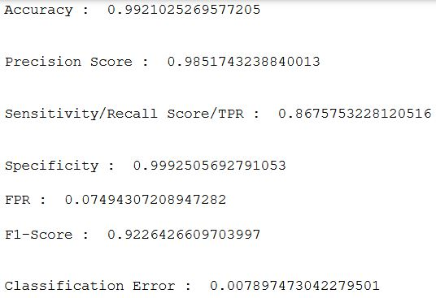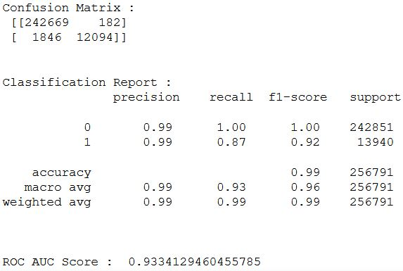

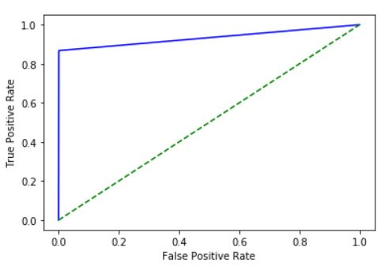

# 

# 4.2 RANDOM FOREST

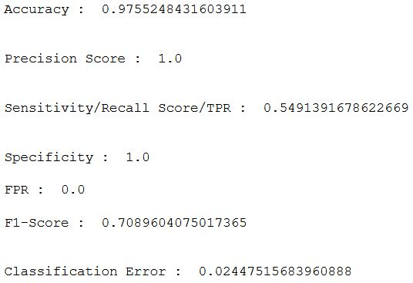

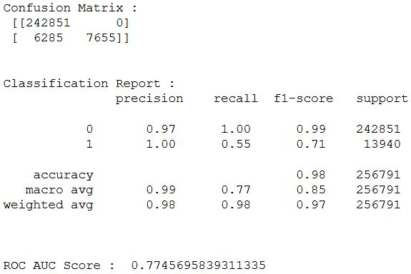

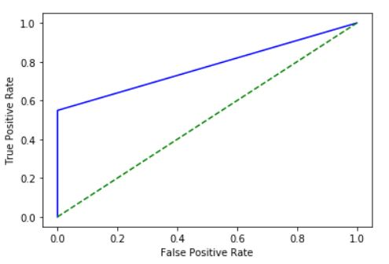

CHAPTER 5: OPTIMAL THRESHOLD SELECTION

For optimal threshold selection we used ROC curve method to identify different thresholds.

After that we ran both our model on values of threshold extracted by ROC function to identify the optimal threshold on the basis of accuracy.

Below is the table of different tables and their respective mean accuracy of both models.

Based on the accuracy score ordered in descending order we selected 0.23 as our optimal threshold

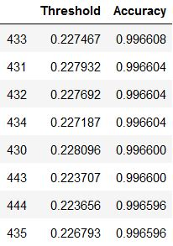

CHAPTER 6: RE-FITTING THE MODELS WITH OPTIMAL THRESHOLD

## 6.1 LOGISTIC REGRESSION MODEL

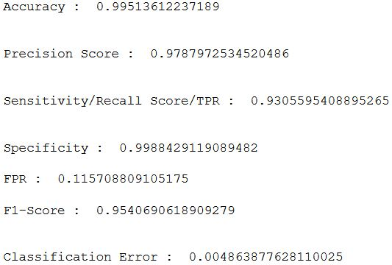

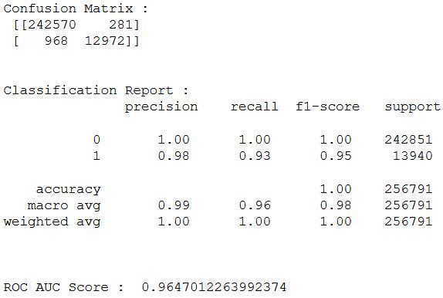

## 6.2 RANDOM FOREST MODEL

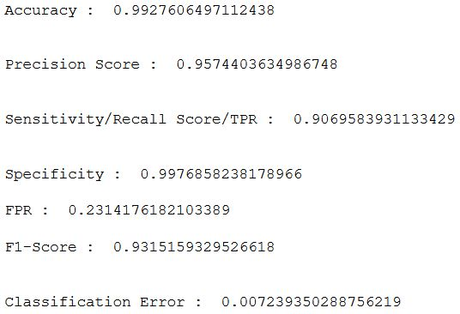

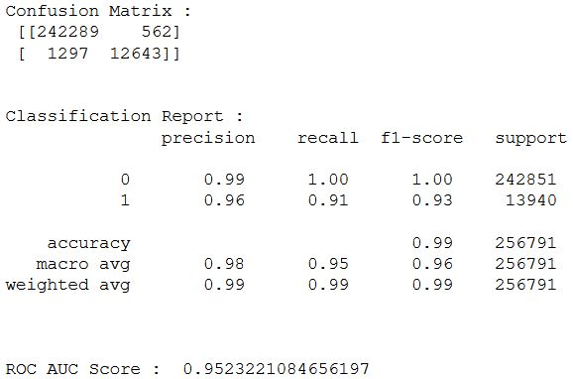

CHAPTER 7: MODEL CROSS-VALIDATION

We used **K-fold stratified cross validation technique** for our data to counter the biasness problem of our target variable and also to validate our model.

## 7.1 LOGISTIC REGRESSION MODEL

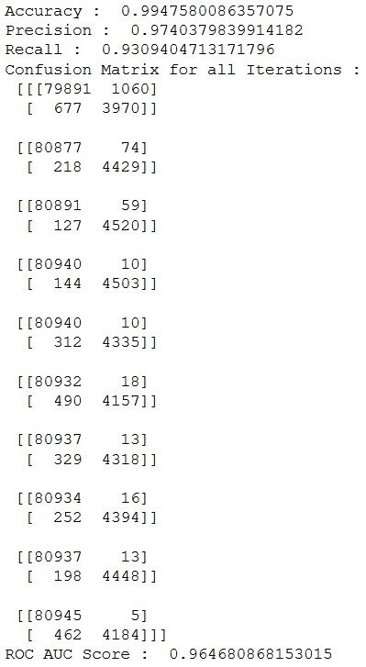

## 7.2 RANDOM FOREST MODEL

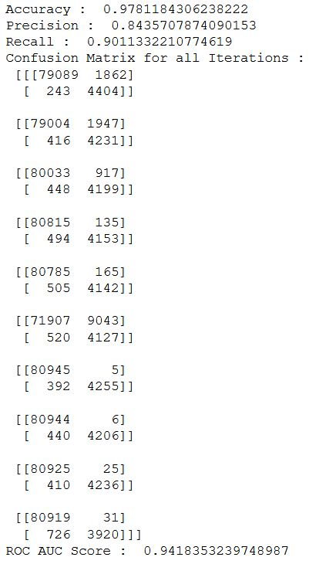

CHAPTER 8: CONCLUSION & KEY FINDINGS

* **CONCLUSION:**

Below is the table comparing different metrics for both the models after cross-validation.

|  |  |  |  |  |  |
| --- | --- | --- | --- | --- | --- |
| Model | Accuracy | Precision | Recall | Error | ROC AUC Score |
| Logistic | 99.4% | 97.4% | 93% | 0.6% | 0.96 |
| Random Forest | 97.8% | 84.3% | 90.1% | 2.2% | 0.94 |

Following are our findings on model selection post cross-validation:

* After analyzing results of cross-validation we observed that logistic model was giving reduced misclassification of FP & FN throughout the iterations whereas Random forest model was giving comparatively high misclassification of FP & FN.
* Classification error, precision and recall values of logistic regression model better than of random forest model.
* Random forest model was also miss-classifying in fluctuating manner throughout the iteration as seen in the results of cross-validation which implicates random forest model is not stable as logistic model.
* Therefore, we select our Logistic regression model as our best fit model for this problem.
* **Business Insights**
* Most of the loans issued were in the range of **8,000 to 20,000 USD**.
* The loans applied by potential borrowers, the amount issued to the borrowers and the amount funded by investors are similarly distributed, meaning that it is most likely that qualified borrowers are going to get the loan they had applied for.
* XYZ Corp. should consider "**Grade**" as a **major variable** while providing loans.
* Applicants having **Mortgage** have applied for **highest average loan amount** and are more likely to default among other categories in Home ownership.
* Applicants who has taken the Loan for '**small business**' and **‘education’** have highest probability of charge off. Hence, XYZ Corp. should take **extra caution** like take some asset or guarantee while approving the loan for purpose of 'small business' and ‘education’
* Borrowers having **higher interest rate** on their loans are more likely to default.
* To counter the effect of high interest rate defaulters, XYZ corporation can try to keep their interest rate **<15%**.

CHAPTER 9: RECOMMENDATION

We might want to look on other techniques or variables to improve the prediction power of the algorithm. One of the drawbacks is just the limited number of people who de-faulted on their loan in the 8 years of data (2007-2015) present on the dataset. We can use an updated data frame which consist next few years values and see how many of the current loans were paid off or defaulted or even charged off. Then these new data points can be used for predicting them or even used to train the model again to improve its accuracy and effectiveness.